
School of Computer Sciences and Engineering
Department of Computer Science and Application

A PROJECT REPORT
ON
“An Automated NLP-Based Framework for Evaluating Academic Project Quality”

UNDER THE FACULTY OF COMPUTER SCIENCE & APPLICATION

Submitted by
Anas Siddiqui (230105311101)
Roshan Singh (230105311102)
Siddhesh Jadhav (230105311074)

Guide
Jyotsna Kulkarni

Assistant Professor

Department of Computer Science and Application
School of Computer Sciences and Engineering
Sandip University, Nashik

B.Sc. Sem-VI
Academic Year 2025 - 2026



Trimbak Road, A/p - Mahiravani, Tal. & Dist. – Nashik, Pin – 422 213
School of Computer Sciences and Engineering
Department of Computer Science and Application
website: http://www.sandipuniversity.edu.in

CERTIFICATE

This is to certify that Mr. Anas Siddiqui, PRN No. 230105311101 Student of BSc. (CS) {AIMLVR} Semester-VI has successfully completed the Project work on Title An Automated NLP-Based Framework for Evaluating Academic Project Quality under my guidance. This report submitted to Department of Computer Science and Application, School of Computer Sciences and Engineering, Sandip University, Nashik in the AY 2025-26 for partial fulfillment and requirement for the End Semester Examination.

Prof. Jyotsna Kulkarni Dr. Vaibhav Sonaje

Project Guide Associate Dean, CSA



Trimbak Road, A/p - Mahiravani, Tal. & Dist. – Nashik, Pin – 422 213
School of Computer Sciences and Engineering
Department of Computer Science and Application
website: http://www.sandipuniversity.edu.in

CERTIFICATE

This is to certify that Mr. Siddhesh Jadhav, PRN No. 230105311075 Student of BSc. (CS) {AIMLVR} Semester-VI has successfully completed the Project work on Title An Automated NLP-Based Framework for Evaluating Academic Project Quality under my guidance. This report submitted to Department of Computer Science and Application, School of Computer Sciences and Engineering, Sandip University, Nashik in the AY 2025-26 for partial fulfillment and requirement for the End Semester Examination.

Prof. Jyotsna Kulkarni Dr. Vaibhav Sonaje

Project Guide Associate Dean, CSA



Trimbak Road, A/p - Mahiravani, Tal. & Dist. – Nashik, Pin – 422 213
School of Computer Sciences and Engineering
Department of Computer Science and Application
website: http://www.sandipuniversity.edu.in

CERTIFICATE

This is to certify that Mr. Roshan Singh, PRN No. 230105311102 Student of BSc. (CS) {AIMLVR} Semester-VI has successfully completed the Project work on Title An Automated NLP-Based Framework for Evaluating Academic Project Quality under my guidance. This report submitted to Department of Computer Science and Application, School of Computer Sciences and Engineering, Sandip University, Nashik in the AY 2025-26 for partial fulfillment and requirement for the End Semester Examination.

Prof. Jyotsna Kulkarni Dr. Vaibhav Sonaje

Project Guide Associate Dean, CSA



Trimbak Road, A/p - Mahiravani, Tal. & Dist. – Nashik, Pin – 422 213
School of Computer Sciences and Engineering
Department of Computer Science and Application
website: http://www.sandipuniversity.edu.in

DECLARATION

We hereby declare that the Project work titled An Automated NLP-Based Framework for Evaluating Academic Project Quality submitted to Sandip University, Nashik is a record of an original work done by us under the guidance of Prof. Jyotsna Kulkarni Department of Computer Science and Application, School of Computer Sciences and Engineering, Sandip University in the AY 2025-26 for a partial fulfillment of requirement for the Completion of End Semester Examination.
This report has not been submitted to any other University or Institute for the award of any degree or diploma.

Student Name: Anas Siddiqui (230105311101)
Student Name: Roshan Singh (230105311102)
Student Name: Siddhesh Jadhav (230105311074)

Date:

Place: Sandip University , Nashik


Trimbak Road, A/p - Mahiravani, Tal. & Dist. – Nashik, Pin – 422 213
School of Computer Sciences and Engineering
Department of Computer Science and Application
website: http://www.sandipuniversity.edu.in

ACKNOWLEDGEMENT

We would like to express my/our special thanks of gratitude’s to our Project guide Jyotsna Kulkarni Department of Computer Science and Application, School of Computer Sciences and Engineering, Sandip University, Nashik for his/her able guidance and support in completing this report.
We would like to extend my gratitude to ___________________, Director, SOCSE, Vaibhav Sonje, Associate Dean, SOCSA for providing us with all the facility that was required to complete this report successfully.
We also thank the management of Sandip University, Nashik for providing me/us infrastructure and lab facility to completion of this Project.
At last, but not the least I/we am/are thankful to all faculty members, staff, and friends who have been always helping and encouraging me/us throughout the period of this internship/project.

Student Name: Anas Siddiqui (230105311101)
Student Name: Roshan Singh (230105311102)
Student Name: Siddhesh Jadhav (230105311074)

Abstract

Evaluation of academic projects is an essential component of higher education, as it reflects students’ understanding of theoretical concepts, problem-solving ability, and practical implementation skills. Traditionally, project evaluation is carried out manually by educators, which often introduces challenges such as subjectivity, inconsistency, and time constraints. Different evaluators may interpret project quality differently, leading to variations in grading and reduced fairness in assessment. With the increasing number of project submissions in academic institutions, there is a growing need for a structured and semi-automated approach that can assist in improving consistency and efficiency in evaluation.
This project proposes an Automated NLP-Based Framework for Evaluating Academic Project Quality, which leverages Natural Language Processing (NLP) techniques to analyse project reports and generate structured evaluation results. The system focuses on textual analysis of project documentation and evaluates it across multiple dimensions, including originality, technical depth, practical relevance, clarity, and consistency. These dimensions are chosen based on commonly used academic evaluation criteria and are essential indicators of project quality.
The proposed framework follows a modular and pipeline-based architecture consisting of multiple stages, including input processing, text extraction, preprocessing, feature extraction, evaluation, and result visualization. In the preprocessing stage, the system cleans and normalizes the extracted text to ensure consistency. Feature extraction techniques are then applied to identify meaningful patterns such as keyword presence, semantic similarity, structural organization, and linguistic characteristics.
The evaluation process is carried out using a rule-based approach, where each dimension is assessed using predefined criteria. This approach ensures transparency and interpretability, allowing users to understand how evaluation scores are generated. Unlike complex machine learning models that often act as black-box systems, the proposed framework prioritizes explainability, making it suitable for academic environments where accountability is important.
The system is implemented using a FastAPI-based backend for handling data processing and evaluation, and a React-based frontend for user interaction and visualization. The results are presented through structured outputs and graphical representations such as radar charts and score breakdown charts, enabling users to easily interpret the evaluation results. The system is designed as a decision-support tool that assists educators by providing objective indicators and structured feedback, rather than replacing human judgment.
The proposed system demonstrates the practical application of NLP techniques in educational assessment and highlights how automated frameworks can enhance traditional evaluation processes. By improving consistency, reducing subjectivity, and providing explainable results, the system contributes to more reliable and efficient academic evaluation. Furthermore, the modular design of the framework allows for future enhancements such as domain-specific customization, integration with advanced machine learning techniques, and expansion to multilingual evaluation systems.
In conclusion, the project provides a scalable and extensible solution for automated academic project evaluation and establishes a foundation for further research in the intersection of NLP and educational technology.

TABLE OF CONTENT

Chapter | Chapter Name | Page No
1 | Introduction
1.1 | Existing System | 14
1.2 | Objectives | 15
1.3 | Scope of Work | 15
1.4 | Operating Environment | 16
1.5 | Description of Technology Used | 17
2 | Literature Review
2.1 | Existing Research | 18
2.2 | Research Gaps | 19
2.3 | Summary | 21
3 | Methodology
3.1 | User Requirement Specification | 22
3.2 | System Overview | 23
3.3 | Data Collection | 23
3.4 | Pre-processing | 24
3.5 | Feature Extraction | 24
3.6 | Evaluation | 25
3.7 | Score Aggregation | 26
3.8 | System Architect | 26
3.9 | Sequence Diagram | 27
3.10 | Deployment Diagram | 28
3.11 | Component Diagram | 28
3.12 | Advantages of propose system | 28
4 | Method and Technology
4.1 | Methods/ Techniques | 29
4.2 | Implementations | 30
4.5 | Entity Relationship Diagram | 31
4.6 | UML diagram | 32
4.7 | Module specification | 32
4.8 | Data flow diagram | 33
4.9 | User Interface Design | 33
4.10 | Use case diagram | 34
4.11 | Output/ Screenshot | 35
5 | Conclusion
5.1 | Summary or Conclusion | 37
5.2 | Limitations | 38
5.3 | Future Enhancements/Work | 39
6 | Bibliography/References | 40
7 | Appendices | 44

List of Figure

Fig. No | Figure Name | Page No.
1 | Sequence Diagram | 27
2 | Deployment Diagram | 28
3 | Component Diagram | 28
4 | ER Diagram | 28
5 | UML Diagram | 31
6 | Data Flow Diagram | 32
7 | User Interface Design | 34
8 | Input File | 34
9 | Work Flow | 35
10 | Dashboard | 35
11 | 3D Plot | 36
12 | Bar Plot Data | 36

Chapter 1: Introduction

1 Introduction

In modern academic environments, project-based evaluation plays a crucial role in assessing students’ understanding, analytical ability, and practical implementation skills. Academic projects are considered a comprehensive measure of a student’s capability, as they integrate theoretical knowledge with real-world application. However, the process of evaluating such projects is traditionally performed manually by educators, which introduces several challenges such as subjectivity, inconsistency, and time constraints.

Manual evaluation often depends on individual judgment, which may vary significantly between evaluators. Different instructors may prioritize different aspects of a project, such as technical depth, presentation quality, or innovation. As a result, the same project may receive different evaluations depending on who reviews it. This lack of standardization leads to inconsistencies and can affect fairness in academic assessment.

With the increasing number of students and project submissions, the workload on educators has also increased significantly. Evaluating each project thoroughly requires substantial time and effort, making it difficult to maintain uniform evaluation standards. This highlights the need for a system that can assist in evaluating academic projects in a more structured and consistent.

Natural Language Processing (NLP), a subfield of artificial intelligence, provides effective techniques for analysing textual data and extracting meaningful information. NLP has been widely used in applications such as automated essay scoring, sentiment analysis, and document classification. These applications demonstrate that textual data can be processed computationally to derive insights related to structure, clarity, and semantic relevance.

The proposed project aims to design and implement an automated framework that leverages NLP techniques to evaluate academic project reports. The system focuses on analysing the textual content of project documents and assessing them across multiple quality dimensions such as originality, technical depth, practical relevance, clarity, and consistency. Unlike black-box machine learning models, the proposed system emphasizes transparency and explainability, allowing users to understand how evaluation scores are generated.

The primary goal of this system is not to replace human evaluators but to support them by providing structured analysis and objective indicators. By introducing a standardized evaluation framework, the system can help reduce subjectivity, improve consistency, and assist educators in making more informed decisions.

Existing System
In the current academic setup, evaluation of student projects is carried out manually by faculty members or evaluation committees. The evaluation process typically involves reviewing project reports, presentations, and demonstrations. While this method allows for human judgment and expertise, it suffers from several limitations that impact the overall quality and fairness of evaluation.
One of the major limitations of the existing system is subjectivity. Since evaluation criteria are often not strictly standardized, different evaluators may interpret project quality differently. For example, one evaluator may focus more on technical implementation, while another may emphasize documentation or presentation. This leads to inconsistencies in grading and may affect the credibility of the evaluation process.
Another significant issue is the time-consuming nature of manual evaluation. Reviewing multiple project reports requires considerable effort, especially when the number of submissions is large. This can lead to rushed evaluations or incomplete analysis, further affecting the reliability of results.
The existing system also lacks structured feedback. In many cases, students receive only final grades without detailed explanations of their strengths and weaknesses. This limits their ability to understand areas for improvement and reduces the effectiveness of the evaluation process as a learning tool.
Additionally, there is no automated mechanism to ensure consistency across evaluations. Each evaluation is independent, and there is no system to compare or standardize results across different projects. This lack of reproducibility makes it difficult to maintain fairness and transparency.
These limitations highlight the need for an automated system that can assist in evaluating academic projects in a more consistent, objective, and structured manner.

Objective
The main objective of this project is to develop an automated system that can evaluate academic project reports using Natural Language Processing techniques. The system is designed to provide structured evaluation results and assist educators in the assessment process.
The specific objectives of the project are as follows:
- To design a framework for evaluating academic project quality based on predefined criteria.
- To analyse project reports using NLP techniques and extract meaningful features from textual data.
- To implement evaluation modules for multiple quality dimensions such as originality, technical depth, practical relevance, clarity, and consistency.
- To generate quantitative scores for each evaluation dimension and combine them into an overall evaluation score.
- To provide explainable feedback that helps users understand the basis of evaluation.
- To develop a user-friendly interface that allows users to upload project reports and view evaluation results.
- To ensure that the system produces consistent and reproducible results for the same input.
These objectives collectively aim to create a system that enhances the efficiency, consistency, and transparency of academic project evaluation.

Scope of Work
The scope of this project is focused on the automated evaluation of academic project reports based on textual analysis. The system is designed to analyse the content of project documents and generate evaluation scores using predefined criteria.
The project includes the following aspects within its scope:
- Processing of project reports in digital format (PDF).
- Extraction and analysis of textual content using NLP techniques.
- Evaluation of project quality based on multiple dimensions such as originality, clarity, and relevance.
- Generation of structured evaluation scores and feedback.
- Visualization of results using charts and user interface components.

However, the project has certain limitations that define its boundaries. The system does not evaluate the actual implementation of the project, such as code correctness, performance, or functionality. It also does not assess domain-specific knowledge beyond textual representation.
The system is intended to function as a decision-support tool rather than a replacement for human evaluators. It provides structured insights that can assist educators in making informed evaluation decisions.

Operating Environment

1.4.1. Software Specification
- Programming Language: Python
- Backend Framework: FastAPI
- Frontend Framework: React.js
- Visualization Library: Chart.js
- Animation Library: Framer Motion
- NLP Libraries: spaCy, Sentence Transformers
These technologies are selected due to their efficiency, scalability, and suitability for building web-based NLP applications.

1.4.2. Hardware Specification
- Processor: Intel i3 or higher
- RAM: Minimum 4GB (8GB recommended)
- Storage: Minimum 10GB free space
- Operating System: Windows/Linux/MacOS
- Web Browser: Google Chrome / Microsoft Edge
The system is lightweight and does not require specialized hardware, making it accessible for academic use.

Description of Technology Used
The project utilizes a combination of modern technologies to implement the evaluation system.
Natural Language Processing (NLP):
NLP techniques are used to analyse textual content and extract meaningful features. These techniques include text preprocessing, tokenization, semantic similarity analysis, and keyword-based evaluation.
FastAPI:
FastAPI is used to develop the backend of the system. It provides a high-performance API framework that allows efficient communication between the frontend and backend components.
React.js:
React is used to build the frontend interface. It enables the development of dynamic and interactive user interfaces that enhance user experience.
Framer Motion:
Framer Motion is used to implement animations and improve the visual appeal of the application, making the interface more engaging and responsive.
Chart.js:
Chart.js is used to visualize evaluation results through charts such as radar charts and bar graphs, allowing users to interpret results easily.
These technologies collectively enable the development of a scalable, efficient, and user-friendly system for automated project evaluation.

Chapter 2: Literature review

The field of automated academic evaluation has gained significant attention with the advancement of Natural Language Processing (NLP) and artificial intelligence techniques. Researchers have explored various approaches to assess textual content such as essays, short answers, and reports using computational methods. The primary goal of these systems is to reduce manual effort, improve consistency, and provide scalable evaluation solutions.
Automated evaluation systems can be broadly categorized into rule-based systems, machine learning-based systems, and hybrid approaches. Rule-based systems rely on predefined linguistic and structural patterns, while machine learning-based systems learn evaluation patterns from labelled data. Hybrid systems combine both approaches to improve accuracy and interpretability.
The relevance of NLP in educational assessment lies in its ability to analyse language structure, semantic meaning, and textual coherence. Techniques such as tokenization, part-of-speech tagging, semantic similarity, and text classification have been widely used to evaluate writing quality. These techniques provide a foundation for developing systems that can approximate human judgment in assessing textual content.
In the context of academic project evaluation, similar principles can be applied to analyse project reports. While most existing research focuses on essay scoring, the methodologies can be extended to evaluate larger and more structured documents such as project reports.

Existing Research
One of the earliest applications of NLP in education is Automated Essay Scoring (AES). Systems such as the Criterion system developed by Burstein et al. demonstrated that linguistic features such as grammar, vocabulary, and organization can be used to evaluate writing quality. These systems showed that computational models could approximate human scoring with reasonable accuracy.
Further research by Ke and Ng (2019) provided a comprehensive survey of automated essay scoring techniques, highlighting the evolution from rule-based approaches to deep learning models. The study emphasized that while machine learning models improve predictive performance, they often lack transparency, making it difficult to interpret evaluation results.
Another important contribution in this domain is the work by Mohler and Mihalcea (2009),
which explored the use of semantic similarity for automatic short answer grading. Their approach demonstrated that comparing student responses with reference answers using similarity measures can provide meaningful evaluation results. This concept is particularly relevant for analysing content relevance in project reports.
Dikli (2006) provided an overview of automated scoring systems and emphasized the importance of combining linguistic features with structural analysis. The study highlighted that automated systems should not only focus on surface-level features but also consider deeper aspects such as coherence and logical flow.
In addition, research on text similarity and semantic analysis by Mihalcea et al. (2006) introduced methods for measuring similarity between textual documents using corpus-based and knowledge-based techniques. These methods are widely used in applications such as plagiarism detection and content analysis.
More recent advancements, such as Sentence-BERT (Reimers & Gurevich, 2019), have improved the ability to capture semantic meaning in text using deep learning-based embeddings. These models enable more accurate similarity comparisons between sentences and documents.
Despite these advancements, most research has been focused on evaluating essays or short answers. Limited work has been done on evaluating full-length academic project reports, which are more complex and require multi-dimensional analysis.

Research Gaps
Although significant progress has been made in automated text evaluation, several gaps still exist in the current research landscape, particularly in the context of academic project evaluation.
Firstly, most existing systems focus on essay scoring or short answer grading. These systems are designed for relatively short and structured responses, whereas academic project reports are longer, more complex, and contain multiple sections such as introduction, methodology, and results. Evaluating such documents requires a more comprehensive and structured approach.
Secondly, many modern systems rely heavily on machine learning and deep learning models. While these models can achieve high accuracy, they often function as black-box systems, making it difficult to interpret how scores are generated. In academic environments, transparency and explainability are crucial, as evaluation results must be justified and

understandable. Thirdly, existing systems typically focus on a single dimension of evaluation, such as grammar or content relevance. However, academic project evaluation requires multi-dimensional analysis, including originality, technical depth, clarity, and consistency. Current research does not adequately address this multi-faceted evaluation requirement.
Another limitation is the lack of adaptability of existing systems. Many models require large labelled datasets for training, which may not be available in all academic contexts. This limits their applicability in smaller institutions or for domain-specific evaluations.
Additionally, there is limited focus on providing structured feedback along with evaluation scores. Most systems generate numerical scores without detailed explanations, reducing their usefulness as learning tools for students.
These gaps highlight the need for a system that is:
- Multi-dimensional in evaluation
- Explainable and transparent
- Applicable to long-form academic documents
- Independent of large training datasets

2.3 Motivation for Proposed System
The limitations of existing systems provide strong motivation for developing a new framework tailored to academic project evaluation.
The proposed system aims to address the identified gaps by adopting a rule-based and NLP-driven approach that prioritizes explainability and structured analysis. Unlike black-box machine learning models, the system provides clear reasoning behind evaluation scores, making it more suitable for academic use.
Another motivation is the need for consistency in evaluation. By standardizing evaluation criteria and applying them uniformly across all project reports, the system can reduce variability in grading and improve fairness.
The system also focuses on multi-dimensional evaluation, recognizing that project quality cannot be assessed using a single metric. By analysing multiple aspects such as originality, clarity, and relevance, the system provides a more comprehensive assessment.
Furthermore, the system is designed to be lightweight and scalable, without requiring large datasets or complex training processes. This makes it practical for implementation in academic institutions with limited resources.

2.4 Summary of Literature Review
The literature review indicates that NLP-based techniques have been successfully applied in automated assessment systems, particularly in essay scoring and short answer grading. These systems demonstrate the potential of computational methods in evaluating textual content.
However, existing approaches have limitations in terms of scope, explainability, and applicability to complex academic documents. There is a clear gap in the development of systems specifically designed for evaluating academic project reports using structured and interpretable methods.
The proposed project builds upon existing research while addressing these limitations by introducing a modular, explainable, and multi-dimensional evaluation framework. This approach ensures that the system is both practical and academically relevant.

Chapter 3: Proposed System/ Methodology

The proposed system is an automated framework designed to evaluate academic project reports using Natural Language Processing (NLP) techniques. The system aims to introduce a structured, consistent, and explainable approach to project evaluation, addressing the limitations of traditional manual assessment methods.
In conventional systems, evaluation is performed manually, which leads to variability in grading due to subjective interpretation. The proposed system reduces this variability by applying predefined evaluation criteria uniformly across all project reports. This ensures consistency, reproducibility, and fairness in evaluation.
The system is designed as a decision-support tool rather than a replacement for human evaluators. It assists educators by providing structured insights and quantitative scores while maintaining transparency in how these scores are generated.
The methodology follows a pipeline-based approach, where the input document is processed in multiple stages, including preprocessing, feature extraction, evaluation, and result visualization. Each stage is modular and independent, allowing flexibility and scalability in system design.

3.1. User Requirement Specification
The system is designed based on the requirements of academic stakeholders, including educators and students.

3.1.1 Functional Requirements
The system must satisfy the following functional requirements:
- The system shall allow users to upload academic project reports in PDF format.
- The system shall extract textual content from uploaded documents.
- The system shall preprocess and clean the extracted text.
- The system shall analyse the document using NLP techniques.
- The system shall evaluate the document across multiple predefined dimensions.
- The system shall compute individual scores for each dimension.
- The system shall generate an overall evaluation score.
- The system shall provide explainable feedback based on analysis.
- The system shall display results using charts and structured output.

3.1.2 Non-Functional Requirements
- The system should produce results within a reasonable time.
- The system should ensure consistency in evaluation for identical inputs.
- The system should be user-friendly and easy to operate.
- The system should be scalable for handling multiple inputs.
- The system should be maintainable and modular.
These requirements ensure that the system is both technically efficient and practically usable.
3.2. System Overview
The proposed system follows a structured workflow that transforms raw project documents into meaningful evaluation outputs.

3.2.1 System Workflow
- User uploads the project report
- System extracts textual content from the document
- Extracted text undergoes preprocessing
- Document is divided into logical sections
- Each section is analysed using NLP techniques
- Evaluation modules compute scores for each dimension
- Scores are aggregated into a final evaluation score
- Results are displayed with charts and feedback
This step-by-step process ensures that the evaluation is systematic and traceable.
3.3. Data Collection
The system operates on textual data obtained from academic project reports. These reports are typically submitted in PDF format and contain structured sections such as introduction, methodology, and results.

3.3.1 Data Source
- Academic project reports
- Sample documents for testing
- Structured textual content

3.3.2 Justification
Unlike machine learning systems that require large labelled datasets, the proposed system uses a rule-based approach. Therefore, it does not depend on extensive training data. This makes the system more practical and easier to implement in academic environments where labelled data may not be available.
3.4 pre-processing
Pre-processing is a critical stage that prepares raw text for analysis. Raw text extracted from PDFs often contains noise, inconsistencies, and irrelevant characters that must be removed.

3.4.1 Steps in Pre-processing
- Text Extraction: Extract text from PDF files using parsing libraries
- Cleaning: Remove unwanted characters, symbols, and formatting issues
- Tokenization: Split text into words and sentences
- Normalization: Convert text to lowercase for consistency
- Stop word Removal: Remove common words that do not add meaningful information

3.4.2 Justification
Pre-processing ensures that the input text is standardized and suitable for analysis. Without proper preprocessing, NLP techniques may produce inaccurate or inconsistent results.
3.5 Feature Extraction
Feature extraction involves identifying important attributes from the text that can be used for evaluation. These features serve as indicators of project quality.

3.5.1 Types of Features
- Lexical Features: Word count, sentence length, vocabulary diversity
- Structural Features: Section organization and distribution
- Semantic Features: Meaning and relevance of content
- Similarity Features: Degree of similarity with generic patterns
- Consistency Features: Alignment between sections

3.5.2 Justification
Feature extraction enables the system to quantify qualitative aspects of project reports. By converting textual information into measurable features, the system can evaluate project quality objectively.

3.6 Evaluation
The system evaluates project reports across multiple dimensions. Each dimension represents a specific aspect of project quality and is analysed using dedicated modules.

3.6.1 Originality Analysis
This module evaluates the uniqueness of the project content.
- Uses semantic similarity techniques
- Detects repetitive or generic content
- Identifies lack of uniqueness
Justification:
Originality is a key indicator of project quality. Projects with highly repetitive or generic content are considered less valuable.

3.6.2 Technical Depth Analysis
This module evaluates the level of technical detail in the project.
- Detects presence of technical keywords
- Measures complexity of explanations
- Analyses depth of methodology
Justification:
Technical depth reflects the student’s understanding and ability to implement concepts.

3.6.3 Practical Relevance Analysis
This module evaluates the applicability of the project.
- Analyses problem statement clarity
- Checks alignment between problem and solution
- Identifies real-world relevance
Justification:
Projects should address meaningful problems and provide practical solutions.

3.6.4 Clarity Analysis
This module evaluates readability and presentation.
- Measures sentence structure
- Checks grammatical consistency
- Evaluates logical flow
Justification:
Clear communication is essential for effective understanding of project work.

3.6.5 Consistency Analysis
This module checks coherence across the document.
- Verifies alignment between sections
- Detects contradictions
- Ensures logical continuity
Justification:
Consistency ensures that the project is well-structured and logically sound.
3.7. Score Aggregation
After evaluating individual dimensions, the system combines the scores to produce a final evaluation result.

3.7.1 Aggregation Method
- Normalize individual scores
- Apply equal or weighted importance
- Compute final score

3.7.2 Output
- Dimension-wise scores
- Overall evaluation score
- Structured feedback
Justification:
Aggregation ensures that all evaluation aspects contribute to the final result in a balanced manner.
3.8 System Architecture
The system follows a layered architecture:

Layers
- User Interface Layer (Frontend)
  - React-based interface
  - Handles user interaction
- Application Layer (Backend)
  - FastAPI server
  - Processes requests

- Processing Layer (NLP Engine)
  - Text analysis
  - Feature extraction
  - Evaluation modules
- Visualization Layer
  - Charts and results display
Justification:
Layered architecture ensures modularity, scalability, and maintainability.

3.9 Sequence Diagram
The sequence diagram represents interaction between system components:
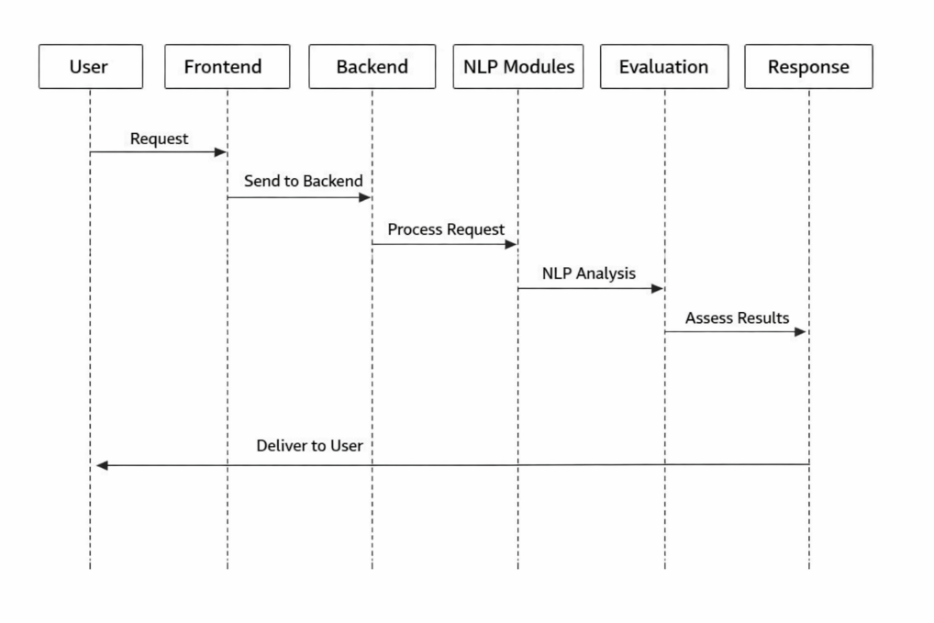
Figure 1. Sequence Diagram

3.10 Deployment Diagram
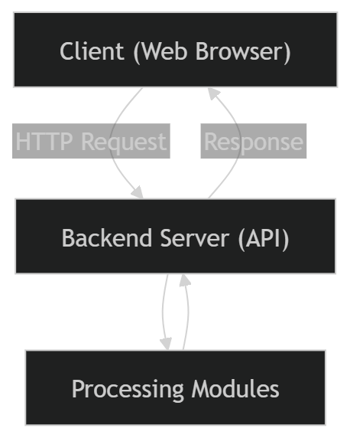
Figure 2. Deployment Diagram
3.11 Component Diagram

Figure 3. Component Diagram

3.12 Advantages of Proposed System
- Reduces subjectivity in evaluation
- Ensures consistent results
- Provides explainable scoring
- Saves time for educators
- Enhances transparency and fairness
- Scalable and adaptable

Chapter 4: Result and Implementation

This chapter presents the implementation details of the proposed system along with the results obtained from evaluating academic project reports. It explains the techniques used, system behaviour, module structure, and output visualization.
The implementation demonstrates how the proposed methodology is translated into a working system capable of processing real project reports and generating structured evaluation results.
4.1. Methods/ Techniques
The system is implemented using a combination of Natural Language Processing (NLP) techniques and rule-based evaluation methods. These techniques are selected to ensure interpretability, efficiency, and suitability for academic evaluation.

Key Techniques Used
1. Text Extraction
PDF parsing techniques are used to extract textual content from project reports. This step converts unstructured documents into analysable text format.
2. Text Preprocessing
The extracted text undergoes preprocessing to remove noise and standardize the content. This includes tokenization, normalization, and removal of irrelevant characters.
3. Semantic Similarity Analysis
Similarity techniques are used to evaluate originality by comparing text patterns. This helps in identifying repetitive or generic content.
4. Keyword-Based Analysis
Domain-specific keywords are used to evaluate technical depth and relevance. The presence and distribution of keywords indicate the richness of content.
5. Structural Analysis
The system analyses document structure by identifying sections and evaluating their organization. This helps assess clarity and consistency.
6. Rule-Based Scoring
Each evaluation dimension is scored using predefined rules. This ensures transparency and avoids the complexity of black-box models.

Justification
These techniques are chosen because they provide:
- Explainable results
- Low computational complexity
- Applicability without large datasets
4.2 Implementation
The system is implemented using a client-server architecture.

Backend Implementation
- Developed using Python and FastAPI
- Handles:
  - File upload processing
  - Text extraction
  - NLP analysis
  - Score computation
The backend processes input data and returns structured results in JSON format.

Frontend Implementation
- Developed using React.js
- Provides:
  - Upload interface
  - Results display
  - Chart visualization
The frontend communicates with the backend through REST APIs.

Integration
The frontend sends the uploaded file to the backend, where it is processed. The backend returns evaluation results, which are then displayed using charts and structured UI components.
4.3 Entity Relationship Diagram
The system includes basic entities required for processing and storing data.

Entities
- User
- Project Report
- Evaluation Result
- Score Details

Relationships
- A user uploads a project report
- A project report generates evaluation results
- Each evaluation result contains multiple score components

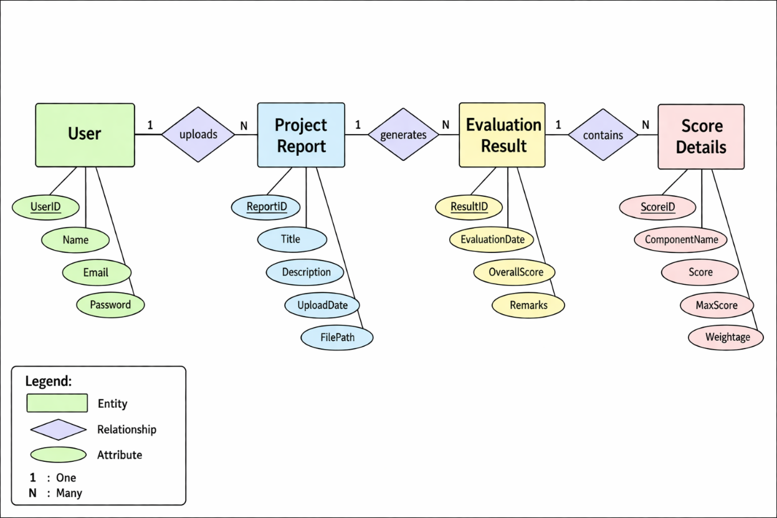
Figure 4 . ER Diagram
  - UML diagram
UML diagrams represent system structure and interaction.

Types of UML used:
- Use Case Diagram
- Sequence Diagram
- Component Diagram

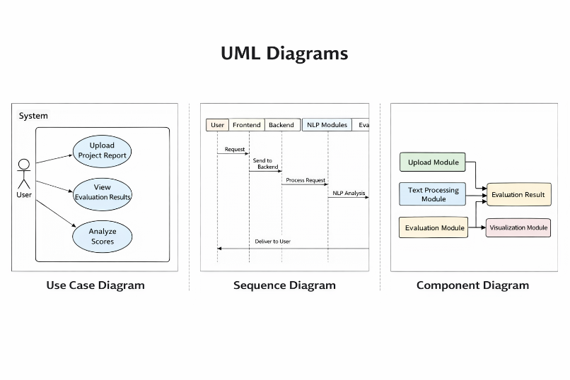
Figure 5 . UML Diagram
  - Module specification
The system is divided into multiple modules:

1. Upload Module
- Accepts project files
- Validates file format
- Sends data to backend

2. Text Processing Module
- Extracts text
- Performs preprocessing
- Prepares data for analysis

3. Evaluation Module
- Performs NLP analysis
- Computes scores
- Applies evaluation rules

4. Visualization Module
- Displays results
- Generates charts
- Provides user feedback

Justification
Modular design ensures:
- Easy maintenance
- Scalability
- Independent development
  - Data flow diagram
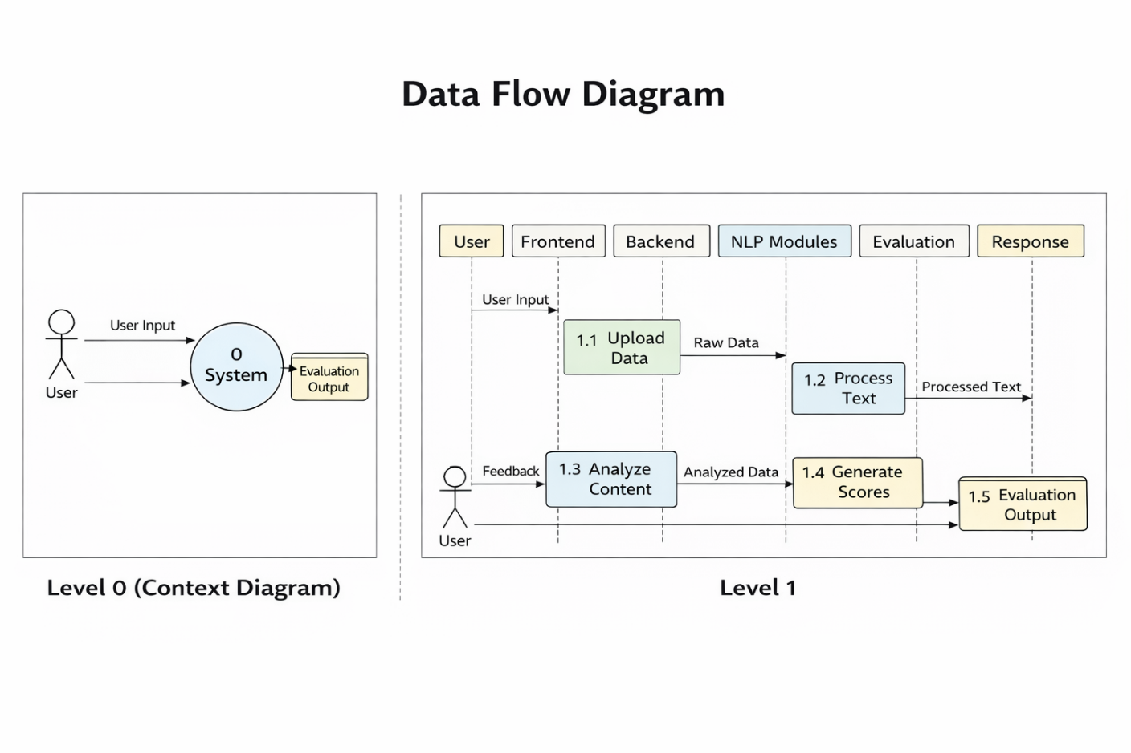
Figure 6 . Data Flow Diagram
  - User Interface Design
The system interface is designed to be simple and user-friendly.

Key Screens
1. Upload Screen
- Allows user to upload PDF
- Displays upload status
2. Processing State
- Shows system activity
- Indicates evaluation progress
3. Results Screen
- Displays evaluation scores
- Shows charts (Radar + Bar)
- Provides structured feedback

Design Principles
- Minimal and clean layout
- Clear hierarchy of information
- Interactive visual elements
  - Use case diagram
The system involves one primary actor:

Actor: User

Use Cases:
- Upload project report
- Initiate evaluation
- View results
- Analyze feedback

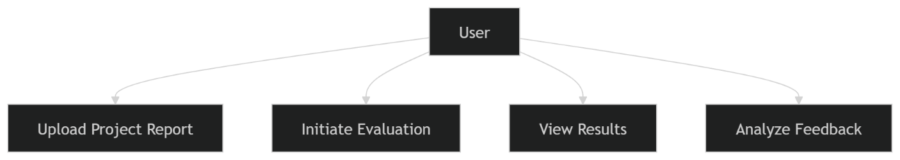
Figure 7 .User Interface design
  - Output/ Screenshot
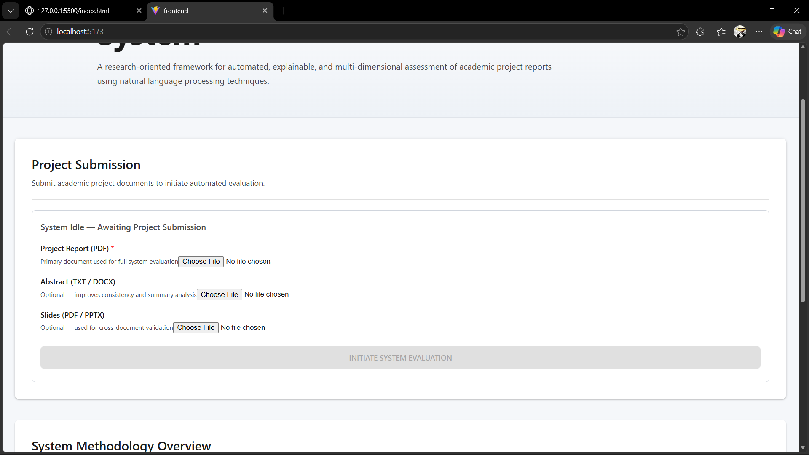
Figure 8 . Input File

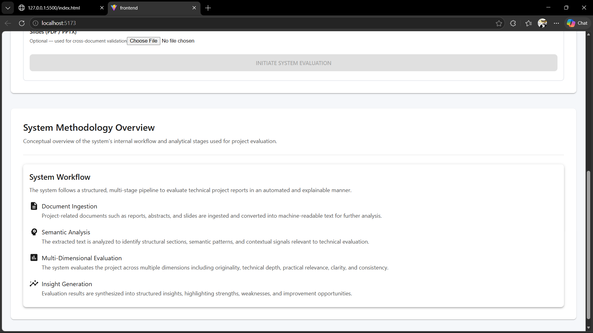
Figure 9. Work Flow
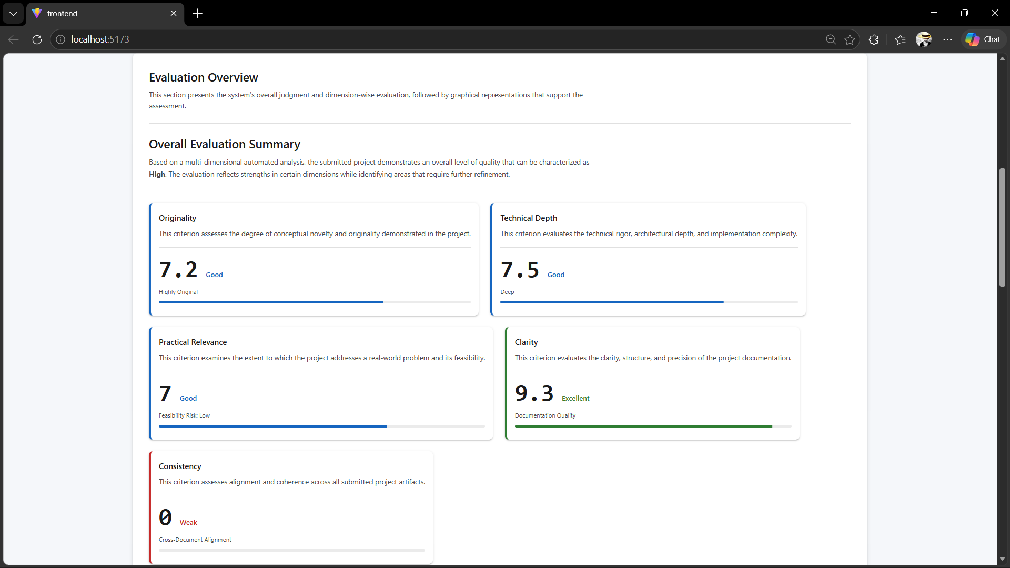
Figure 10. Dashboard

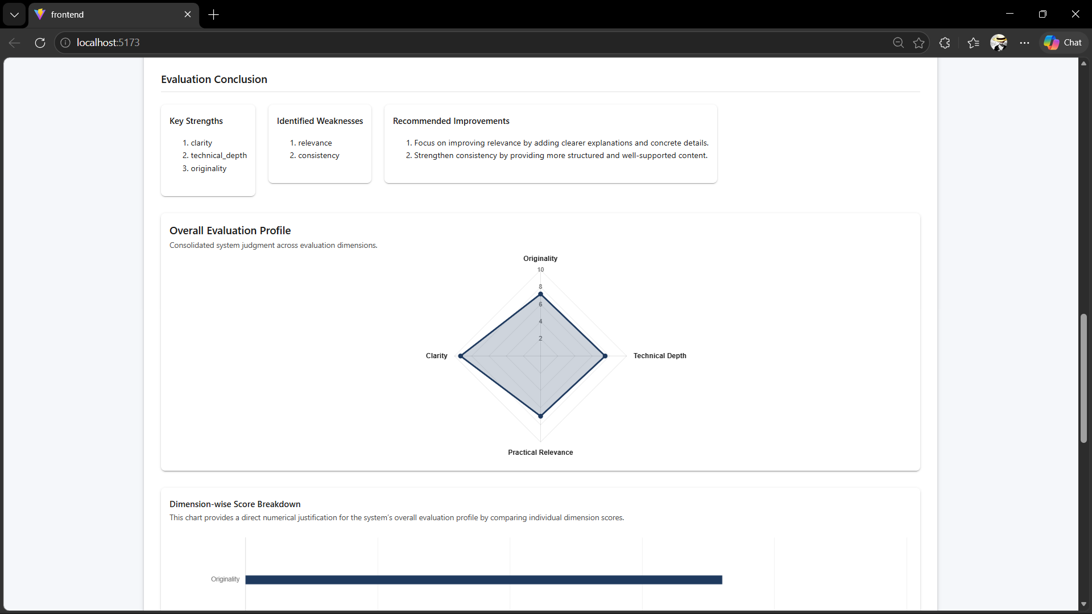
Figure 11. 3d Plot
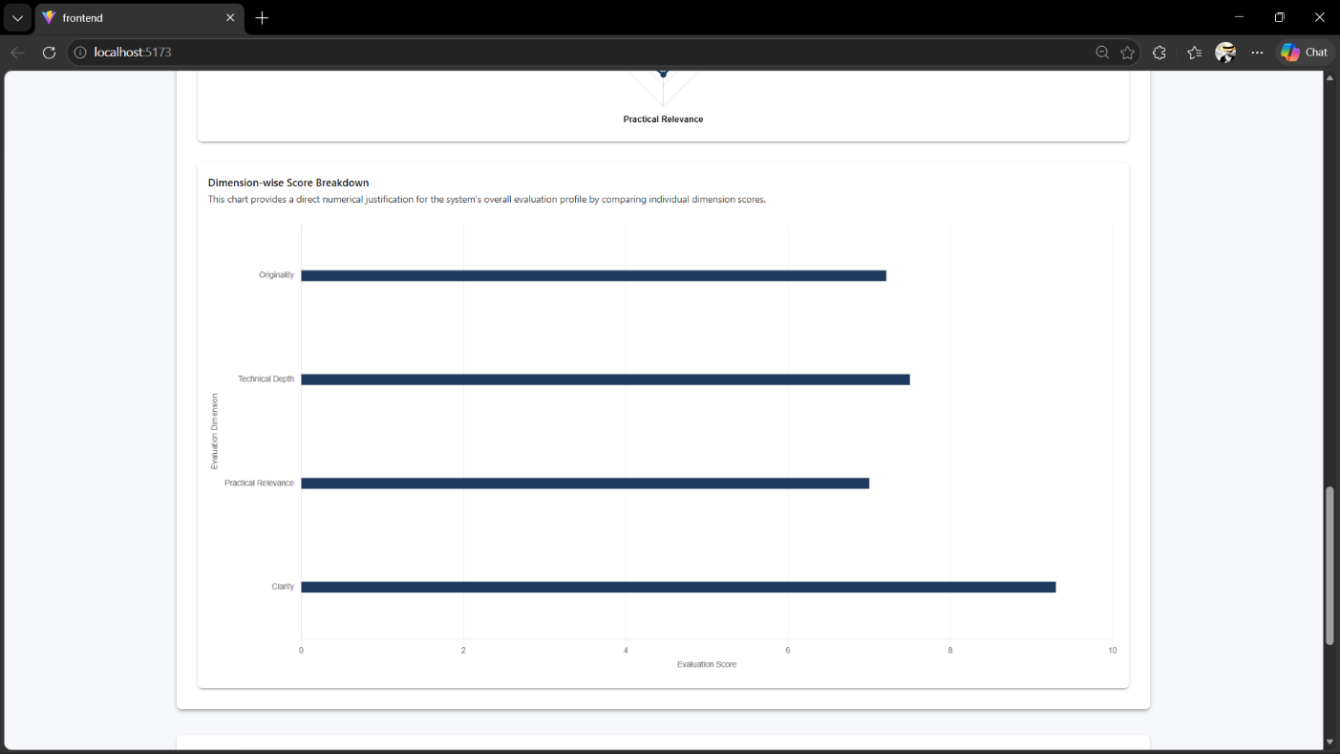
Figure 12 . Bar plot of Data

Chapter 5: Conclusion

5.1 Conclusion
The project titled “An Automated NLP-Based Framework for Evaluating Academic Project Quality” presents a structured and systematic approach to addressing the challenges associated with traditional academic project evaluation. In conventional evaluation systems, the assessment of project reports is largely dependent on manual review, which introduces subjectivity, inconsistency, and variability in grading. These limitations highlight the need for an approach that can support evaluators by providing standardized and objective insights.
The proposed system successfully demonstrates how Natural Language Processing (NLP) techniques can be applied to analyse academic project reports and generate meaningful evaluation results. By processing textual content and extracting relevant features, the system evaluates projects across multiple dimensions such as originality, technical depth, practical relevance, clarity, and consistency. This multi-dimensional evaluation ensures that project quality is assessed comprehensively rather than relying on a single metric.
One of the key contributions of this project is the emphasis on explainability. Unlike many modern systems that rely on complex machine learning models, the proposed framework adopts a rule-based and transparent approach. This allows users to understand how evaluation scores are derived and what factors influence the results. In academic environments, where fairness and accountability are critical, such transparency is essential.
The system also introduces a modular architecture that separates different stages of processing, including text extraction, preprocessing, feature extraction, evaluation, and visualization. This modular design enhances the scalability and maintainability of the system, making it adaptable for future enhancements.
From an implementation perspective, the system successfully integrates backend processing using FastAPI with a user-friendly frontend developed using React. The inclusion of visualization techniques such as radar charts and score breakdown charts improves the interpretability of results and enhances user experience.
Furthermore, the system achieves consistency in evaluation by applying predefined rules uniformly across all inputs. This ensures that similar inputs produce similar outputs, thereby improving reliability and reducing bias. The system also reduces the time required for evaluation, making it suitable for handling large numbers of project submissions.
Overall, the project demonstrates the practical applicability of NLP in educational assessment and highlights how automated systems can assist educators in decision-making. It reinforces the idea that technology can enhance traditional processes by improving efficiency, consistency, and transparency, while still preserving the importance of human judgment.

5.2 Limitations
Despite the successful implementation of the proposed system, certain limitations exist that define the boundaries of the project and provide scope for future improvements.
One of the primary limitations of the system is that it relies solely on textual analysis of project reports. While NLP techniques are effective for analysing written content, they cannot evaluate non-textual aspects of a project, such as code quality, system functionality, or implementation efficiency. As a result, the evaluation is limited to documentation quality rather than overall project performance.
Another limitation is the dependency on document structure and quality. The system assumes that project reports follow a reasonably structured format with identifiable sections such as introduction, methodology, and results. If the document is poorly formatted or lacks clear structure, the accuracy of evaluation may be affected.
The originality analysis in the system is based on similarity measures and predefined patterns. While this approach can detect repetitive or generic content, it may not fully capture the conceptual originality of ideas. True innovation often requires deeper contextual understanding, which is difficult to achieve using rule-based methods alone.
The system also uses predefined rules for evaluation, which may not be adaptable to all domains or project types. Different academic disciplines may have different evaluation criteria, and a generalized rule-based system may not fully capture domain-specific requirements.
Another limitation is the absence of large-scale validation using real-world datasets. The system has been tested on sample inputs, but extensive validation across diverse datasets would be required to assess its robustness and generalizability.
Additionally, the system does not incorporate advanced machine learning or deep learning techniques. While this decision improves explainability and simplicity, it may limit the system’s ability to capture complex patterns and improve accuracy.
Finally, the system is designed as a decision-support tool and not as a standalone evaluation system. Human judgment is still required to interpret results and make final decisions.

5.3 Future Enhancements/Work
The proposed system provides a strong foundation for automated academic project evaluation; however, several enhancements can be implemented to improve its functionality, accuracy, and applicability.
One potential enhancement is the integration of machine learning or deep learning models to complement the existing rule-based system. Hybrid approaches combining rule-based evaluation with learned models can improve accuracy while maintaining a level of interpretability.
Another important area for improvement is domain-specific customization. The system can be extended to support different academic disciplines by incorporating domain-specific evaluation criteria, keywords, and scoring rules. This would make the system more adaptable and relevant for various fields of study.
The inclusion of code analysis capabilities is another valuable enhancement. By integrating tools that analyse source code, the system can evaluate implementation quality, efficiency, and correctness, providing a more comprehensive assessment of projects.
Future work can also focus on improving originality detection by incorporating advanced plagiarism detection techniques and semantic analysis. This would enable the system to better identify conceptual similarities and improve evaluation accuracy.
The system can be extended to support multiple languages, enabling evaluation of project reports written in different languages. This would increase its usability in diverse academic environments.
Another enhancement is the implementation of comparative analysis features, allowing users to compare multiple project reports side by side. This would help educators identify relative strengths and weaknesses more effectively.
The user interface can also be further improved by adding features such as report export, detailed analytics, and interactive feedback. This would enhance usability and provide additional value to users.
Additionally, large-scale testing and validation using real academic datasets can be conducted to evaluate system performance and improve reliability.
Finally, integration with academic management systems can be explored, enabling seamless submission, evaluation, and record management within institutional workflows.

Bibliography
[1] J. Burstein, M. Chodorow, and C. Leacock,
“Automated Essay Evaluation: The Criterion Online Writing Service,”
AI Magazine, vol. 25, no. 3, pp. 27–36, 2004.
[2] Y. Attali and J. Burstein,
“Automated Essay Scoring with e-rater® V.2,”
JTLA, vol. 4, no. 3, 2006.
[3] S. Dikli,
“An Overview of Automated Scoring of Essays,”
Journal of Technology, Learning, and Assessment, 2006.
[4] M. Mohler and R. Mihalcea,
“Text-to-text Semantic Similarity for Automatic Short Answer Grading,”
EACL, 2009.
[5] R. Mihalcea, C. Corley, and C. Strapparava,
“Corpus-based and Knowledge-based Measures of Text Semantic Similarity,”
AAAI, 2006.
[6] Z. Ke and V. Ng,
“Automated Essay Scoring: A Survey of the State of the Art,”
IJCAI, 2019.
[7] N. Reimers and I. Gurevych,
“Sentence-BERT: Sentence Embeddings using Siamese BERT Networks,”
EMNLP, 2019.
[8] J. Devlin et al.,
“BERT: Pre-training of Deep Bidirectional Transformers for Language Understanding,”
NAACL, 2019.
[9] A. Vaswani et al.,
“Attention Is All You Need,”
NeurIPS, 2017.
[10] T. Mikolov et al.,
“Efficient Estimation of Word Representations in Vector Space,”
arXiv, 2013.

🔹 NLP & Text Processing
[11] D. Jurafsky and J. H. Martin,
Speech and Language Processing, 3rd ed., 2023.

[12] C. D. Manning et al.,
“Introduction to Information Retrieval,” Cambridge University Press, 2008.
[13] T. Pedersen et al.,
“WordNet-based Measures of Semantic Similarity,” AAAI, 2004.
[14] G. Salton and C. Buckley,
“Term-weighting Approaches in Automatic Text Retrieval,”
Information Processing & Management, 1988.
[15] K. Sparck Jones,
“A Statistical Interpretation of Term Specificity,”
Journal of Documentation, 1972.

🔹 Educational Assessment Systems
[16] D. M. Williamson, I. I. Bejar, and R. J. Mislevy,
“Automated Scoring of Complex Tasks,”
Educational Measurement, 2006.
[17] S. M. Brookhart,
How to Create and Use Rubrics for Formative Assessment, 2013.
[18] M. Shermis and J. Burstein,
Handbook of Automated Essay Evaluation, Routledge, 2013.
[19] P. Foltz et al.,
“The Intelligent Essay Assessor,”
IEEE Intelligent Systems, 1999.
[20] T. Landauer et al.,
“Latent Semantic Analysis,” Psychological Review, 1998.

🔹 Similarity, NLP & Evaluation
[21] S. Deerwester et al.,
“Indexing by Latent Semantic Analysis,”
JASIS, 1990.
[22] J. Pennington et al.,
“GloVe: Global Vectors for Word Representation,”
EMNLP, 2014.
[23] Y. LeCun et al.,
“Deep Learning,” Nature, 2015.
[24] I. Goodfellow et al.,
Deep Learning, MIT Press, 2016.
[25] T. Brown et al.,
“Language Models are Few-Shot Learners,”
NeurIPS, 2020.

🔹 Explainability & AI Ethics
[26] D. Gunning,
“Explainable Artificial Intelligence (XAI),”
DARPA Report, 2017.
[27] R. Guidotti et al.,
“A Survey of Methods for Explaining Black Box Models,”
ACM Computing Surveys, 2018.
[28] B. Mittelstadt et al.,
“The Ethics of Algorithms,”
Big Data & Society, 2016.
[29] S. Barocas et al.,
Fairness and Machine Learning, 2019.

🔹 Modern NLP & Applications
[30] T. Kenter and M. de Rijke,
“Short Text Similarity with Word Embeddings,”
CIKM, 2015.
[31] Y. Liu et al.,
“RoBERTa: A Robustly Optimized BERT Approach,”
arXiv, 2019.
[32] K. Clark et al.,
“ELECTRA: Pre-training Text Encoders,”
ICLR, 2020.
[33] A. Radford et al.,
“Language Models are Unsupervised Multitask Learners,”
OpenAI, 2019.

🔹 NLP in Education
[34] K. Alhawiti and Y. Abdelhamid,
“NLP in Education: A Systematic Review,”
Education and IT, 2017.
[35] R. Baker and K. Yacef,
“The State of Educational Data Mining,”
JEDM, 2009.
[36] C. Rosé et al.,
“Automatic Analysis of Student Writing,”
AI Magazine, 2019.

🔹 Additional Supporting Works
[37] S. Bird et al.,
Natural Language Processing with Python, O’Reilly, 2009.
[38] F. Chollet,
Deep Learning with Python, Manning, 2017.
[39] A. Ng,
“Machine Learning Yearning,” 2018.
[40] J. Eisenstein,
Introduction to NLP, MIT Press, 2019.
[41] H. Schütze et al.,
“Word Space Models,” Computational Linguistics, 2008.
[42] J. Blei et al.,
“Latent Dirichlet Allocation,”
Journal of Machine Learning Research, 2003.

Appendices
The appendices section contains supporting materials and supplementary information related to the project. These materials provide additional details that support the implementation, analysis, and results presented in earlier chapters.
The purpose of including appendices is to:
- Provide detailed technical information without interrupting the main flow of the report
- Present supporting data and outputs
- Enhance clarity and transparency of the project

7.1 Sample Input (Project Report)
This section includes examples of input data used by the system.

Description
The system accepts project reports in PDF format. These documents typically include sections such as:
- Introduction
- Problem Statement
- Methodology
- Results
- Conclusion

Example Input Content
Title: Smart Attendance System
Introduction:
The system aims to automate attendance using facial recognition...
Methodology:
The system uses image processing and machine learning...
Conclusion:
The system improves efficiency and reduces manual work...

Purpose
This sample input demonstrates the type of data processed by the system and helps in understanding how textual content is analysed.

7.2 Sample Output (Evaluation Result)
This section shows the output generated by the system.

Output Includes:
- Originality Score
- Technical Depth Score
- Practical Relevance Score
- Clarity Score
- Consistency Score
- Overall Evaluation Score

Example Output
Originality: 7.5 / 10
Technical Depth: 8.0 / 10
Practical Relevance: 7.0 / 10
Clarity: 6.5 / 10
Consistency: 7.5 / 10
Overall Score: 7.3 / 10

Explanation
The output provides both numerical scores and interpretive insights, allowing users to understand the strengths and weaknesses of the project.

7.3 API Structure (Backend Response)
This section includes the structure of the backend response.

Sample JSON Response
{
"originality": 7.5,
"technical_depth": 8.0,
"practical_relevance": 7.0,
"clarity": 6.5,
"consistency": 7.5,
"overall_score": 7.3
}

Purpose
This helps in understanding how the frontend receives and processes evaluation data.

7.4 Key Code Snippets
This section includes important parts of the implementation.

Example: File Upload (Backend)
@app.post("/upload")
async def upload_file(file: UploadFile):
content = await file.read()
text = extract_text(content)
result = evaluate(text)
return result

Example: Frontend API Call
const formData = new FormData();
formData.append("file", selectedFile);
axios.post("http://localhost:8000/upload", formData)
.then(res => setResult(res.data));

Purpose
These snippets demonstrate how the system is implemented and how components interact.

7.5 Test Cases
This section includes test cases used to validate the system.
Test Case | Input Type | Expected Result
TC1 | Well-structured project | High scores
TC2 | Poorly written report | Low clarity
TC3 | Repetitive content | Low originality
TC4 | Missing sections | Low consistency

Purpose
Test cases help verify that the system behaves correctly under different conditions

7.7 Additional Notes
- The system is designed for academic use
- Results are consistent for the same input
- Evaluation is explainable and transparent

